

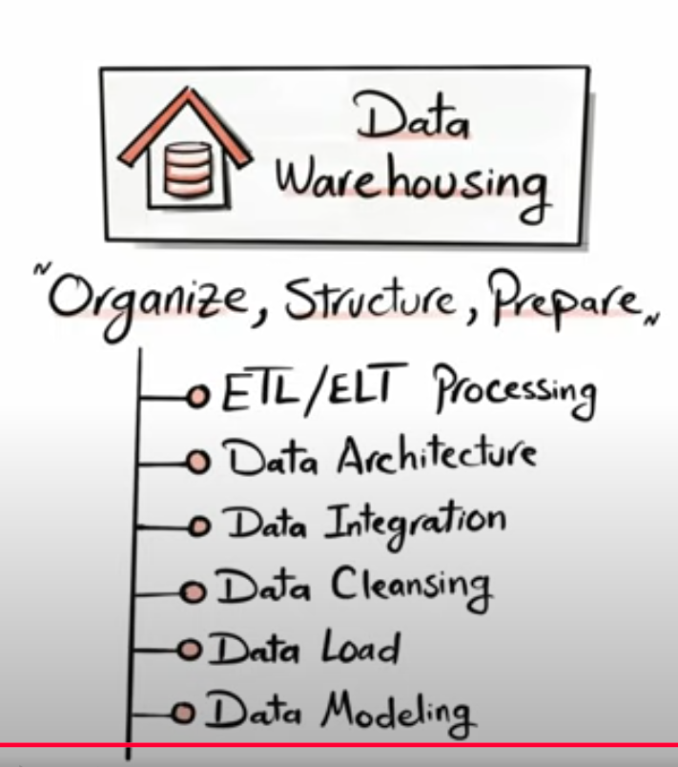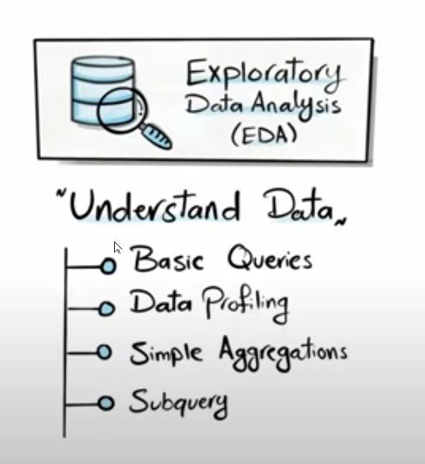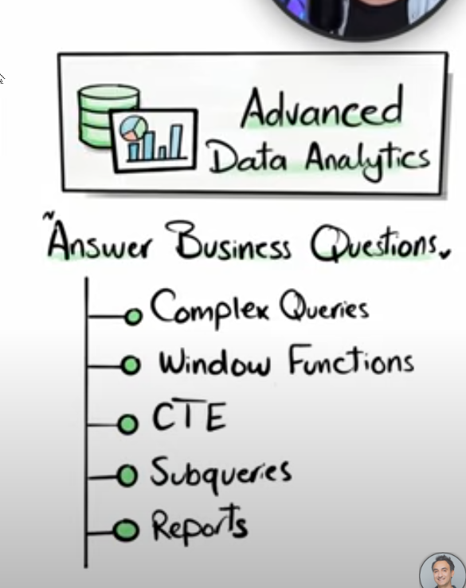

ETL (Extract Transform and Load)

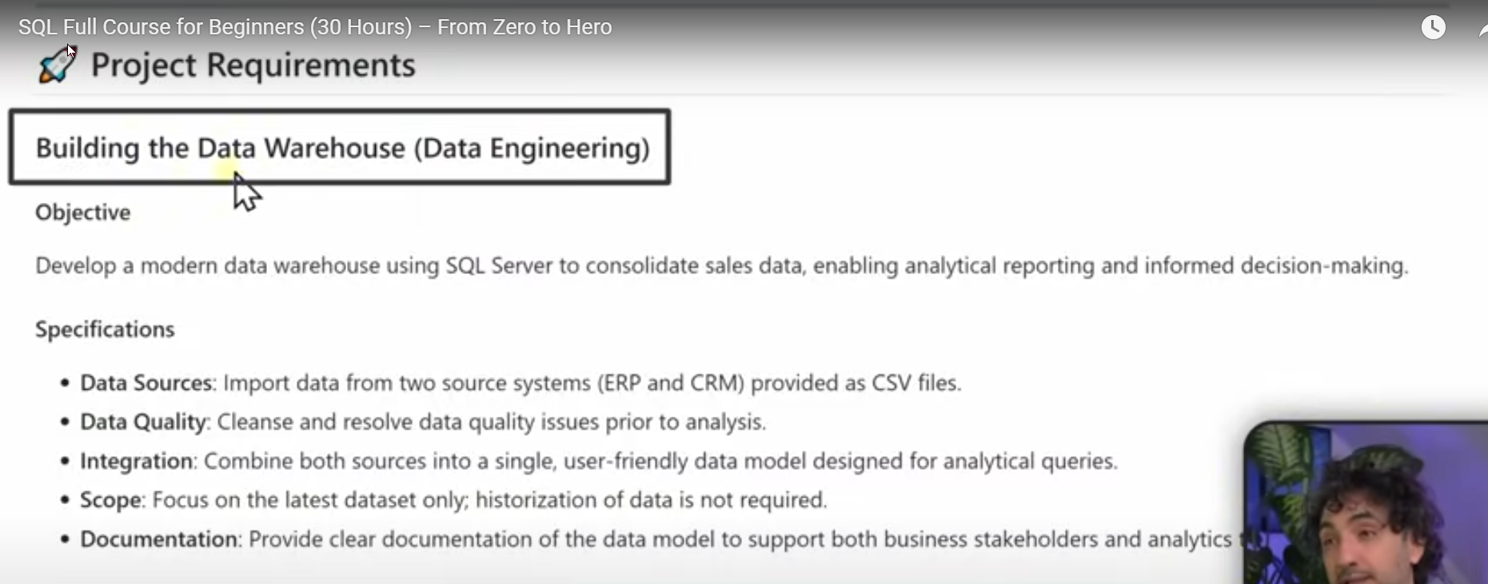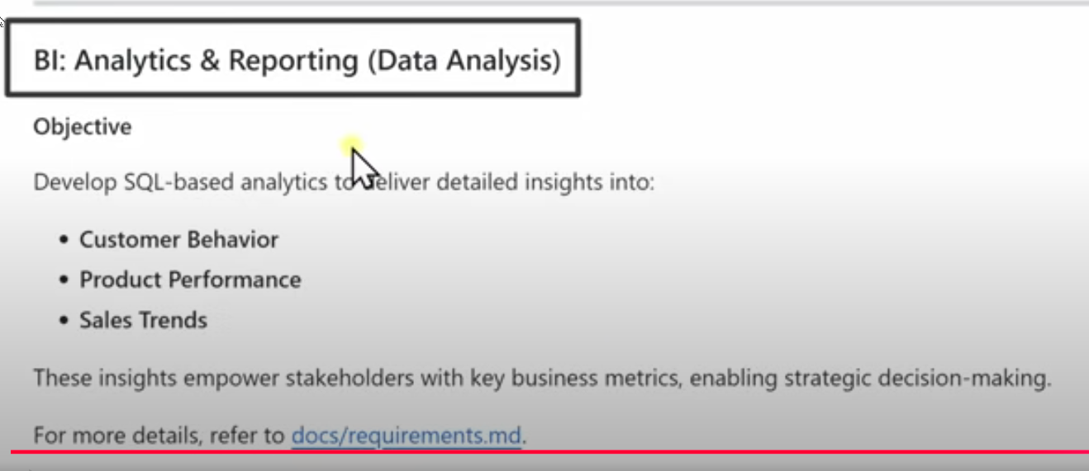





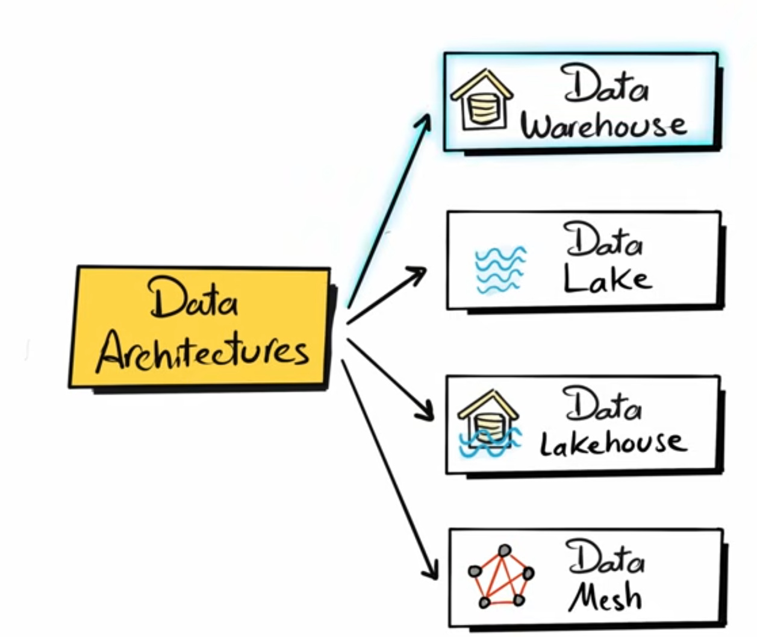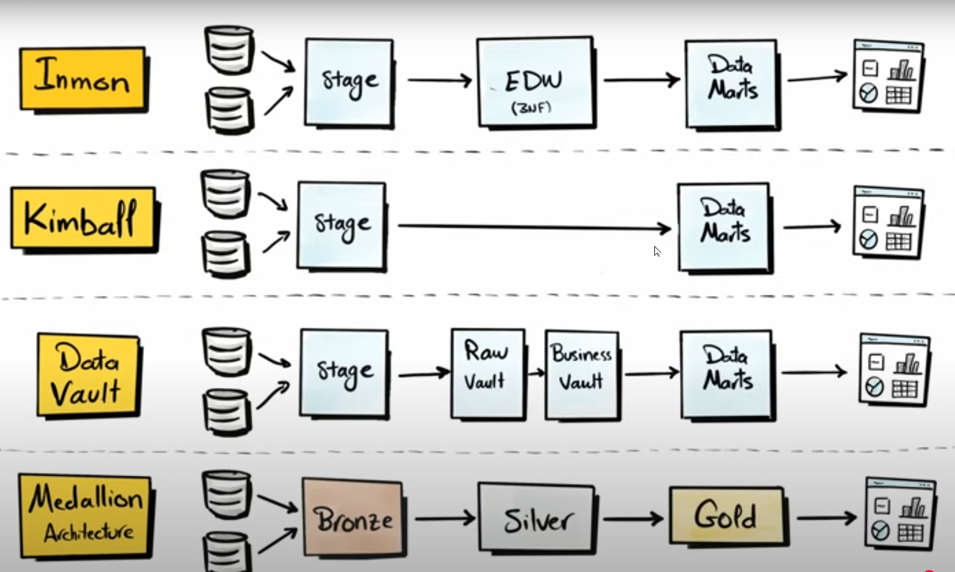



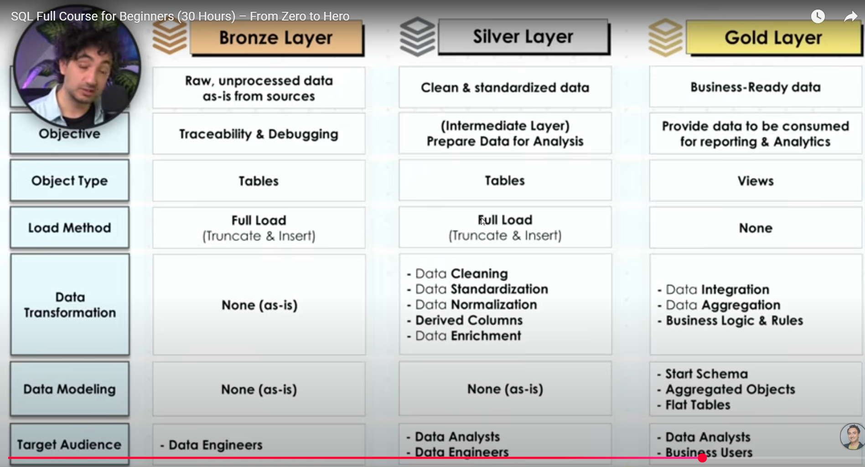

SOC separation of concerns

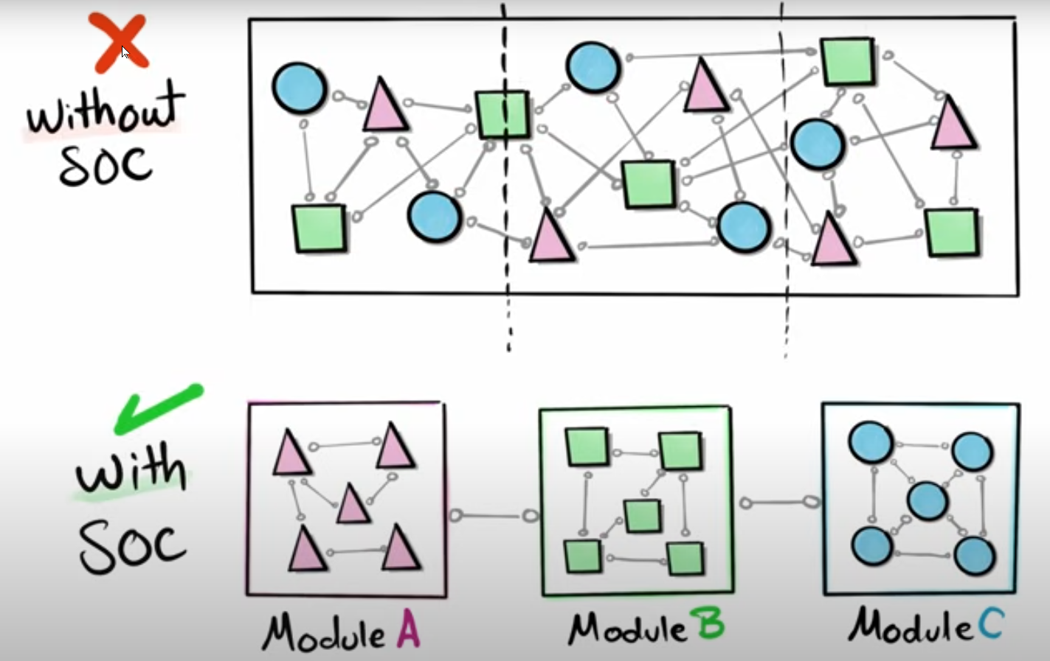

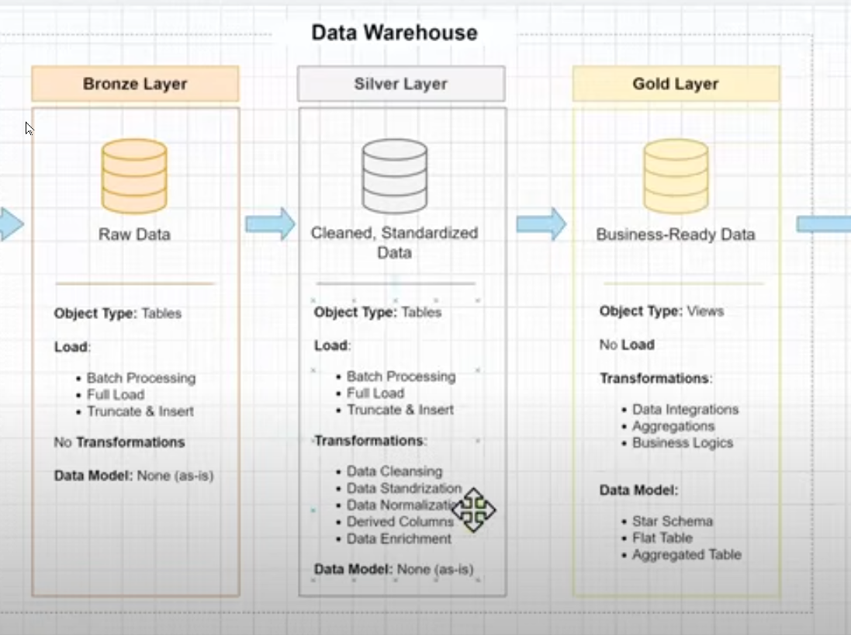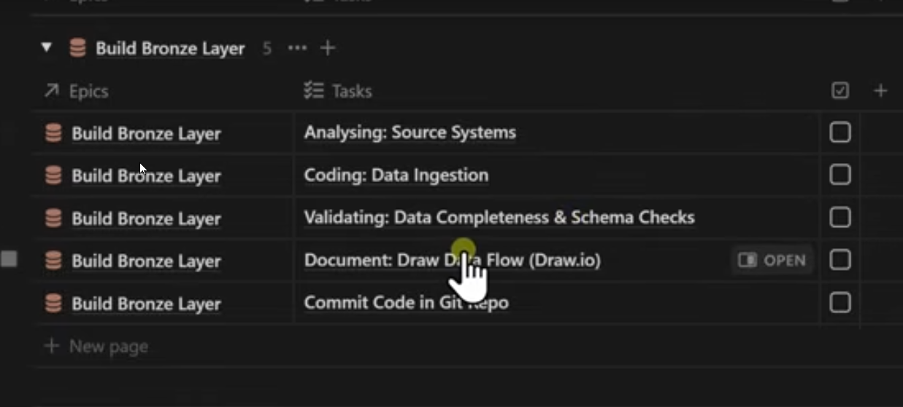

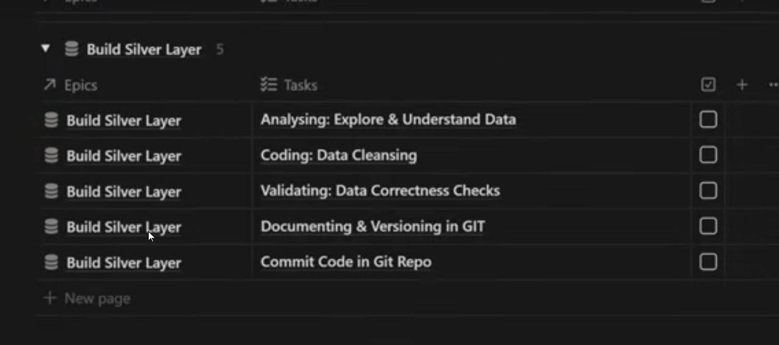

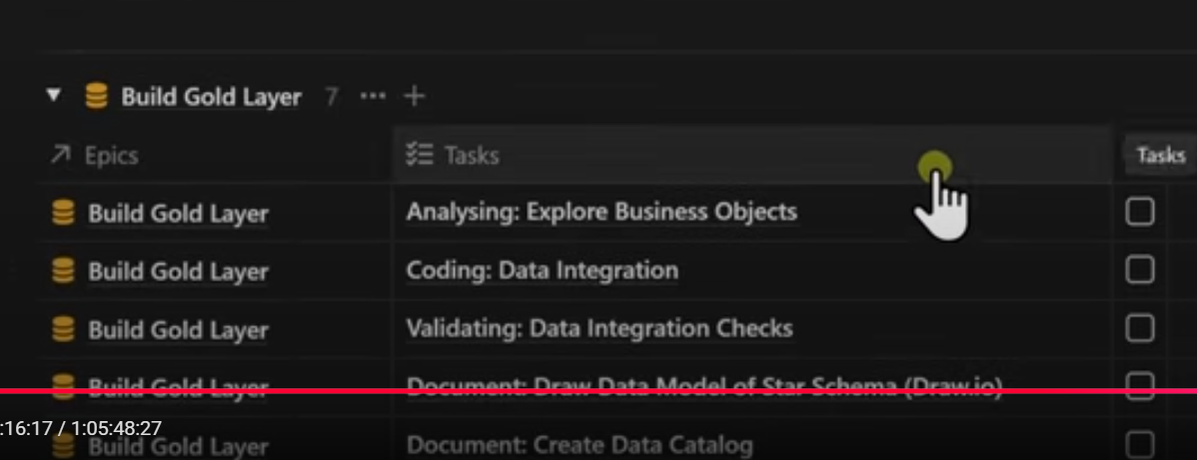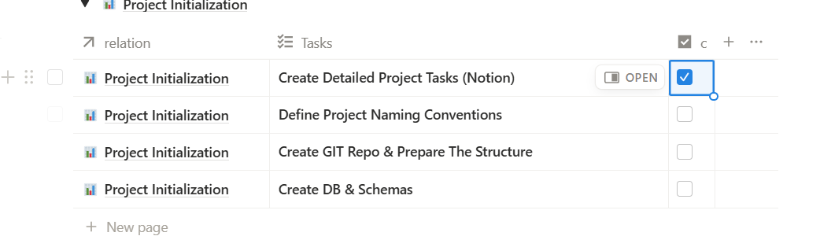

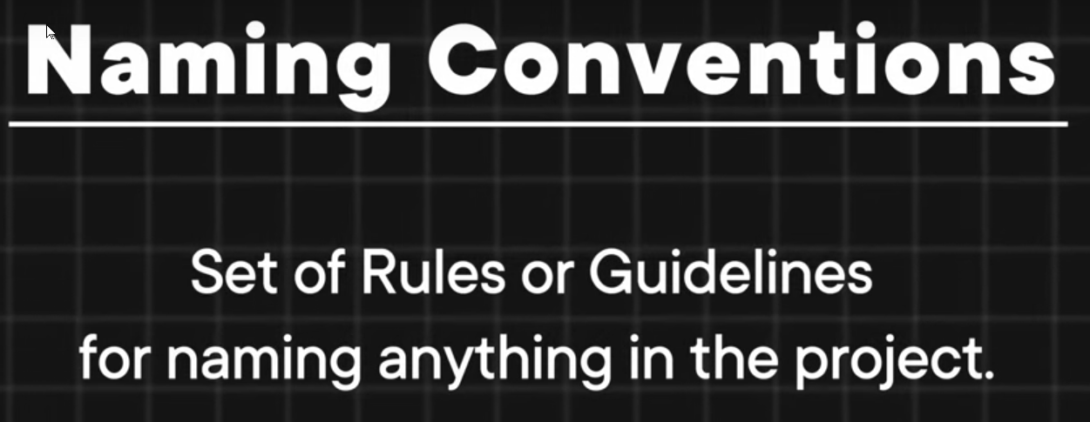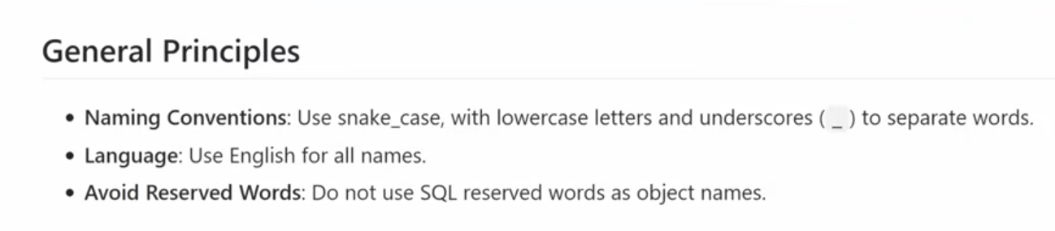

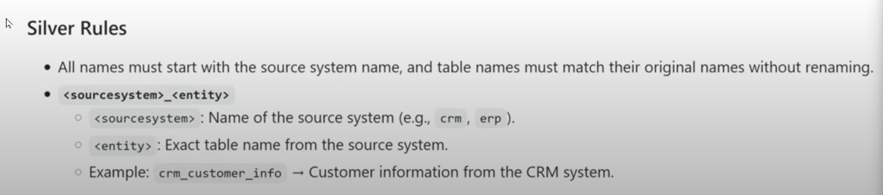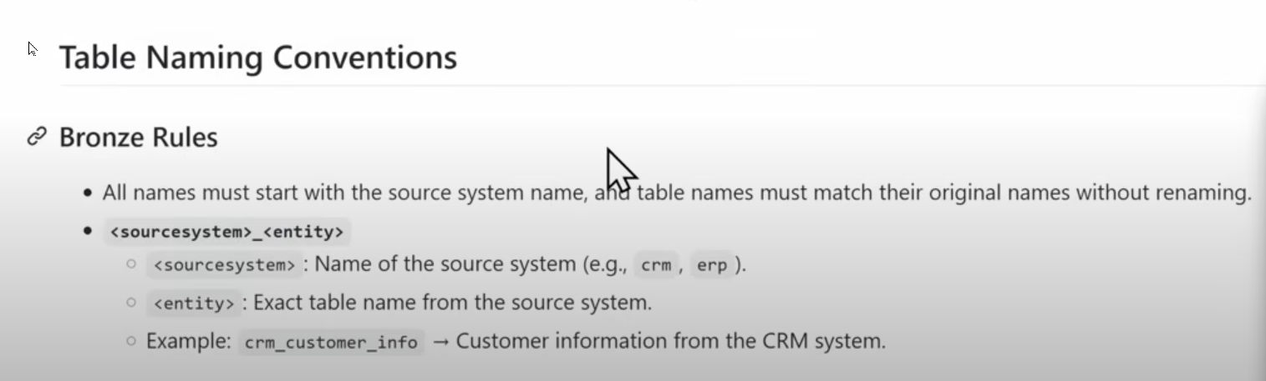

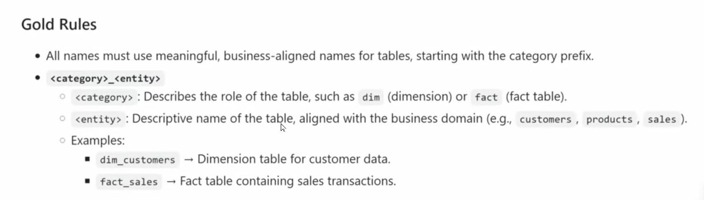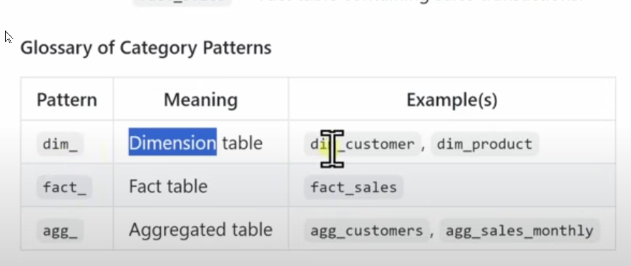

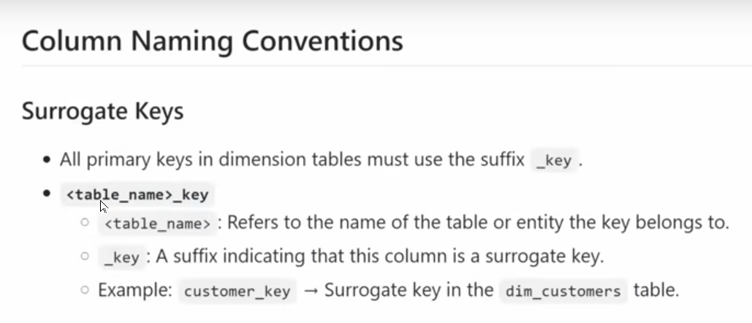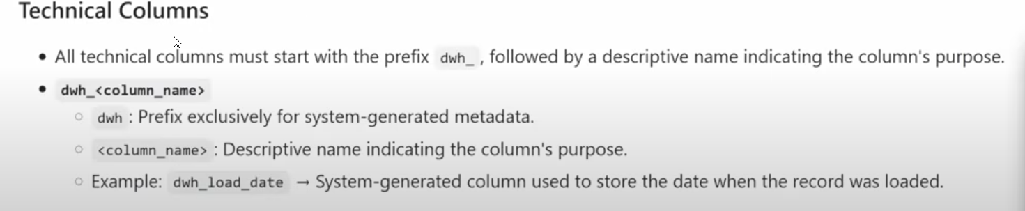

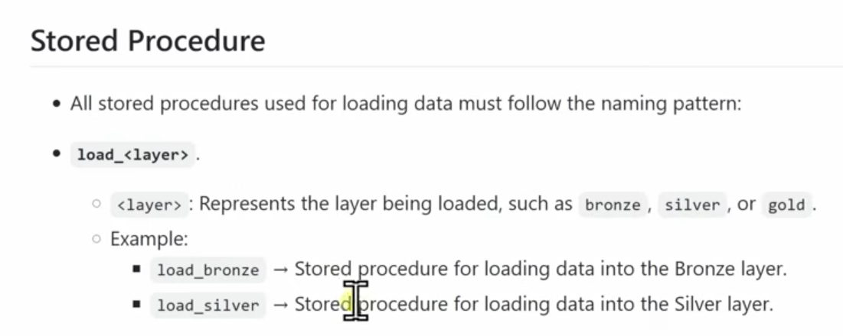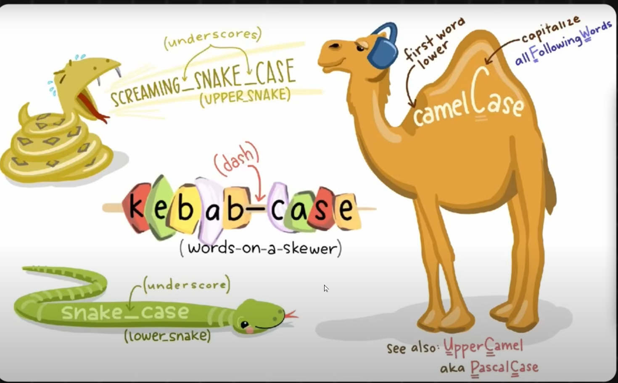



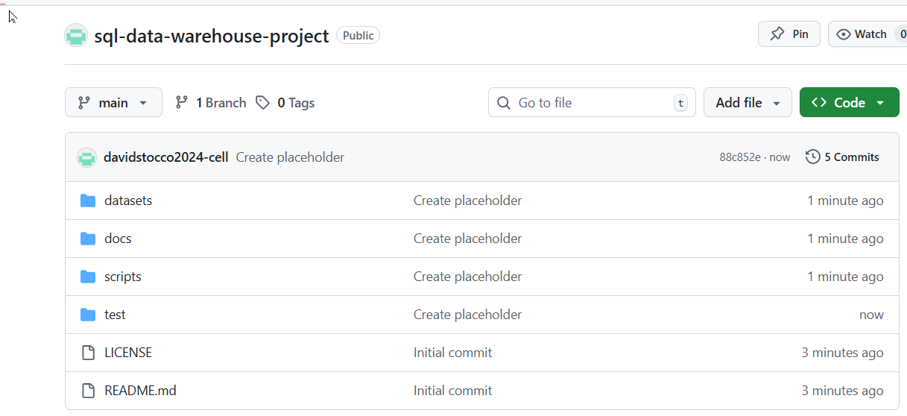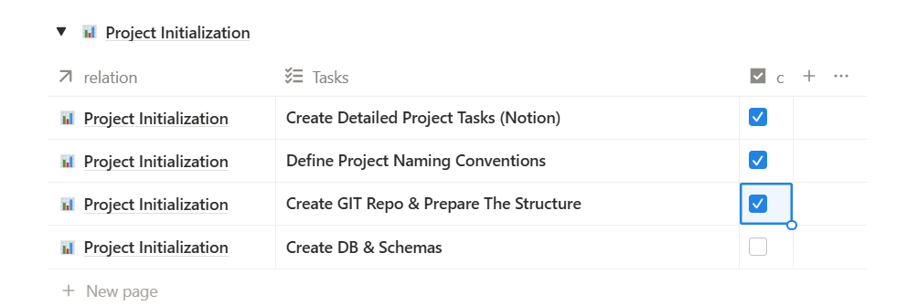

My first project repository!!! md significa mark down



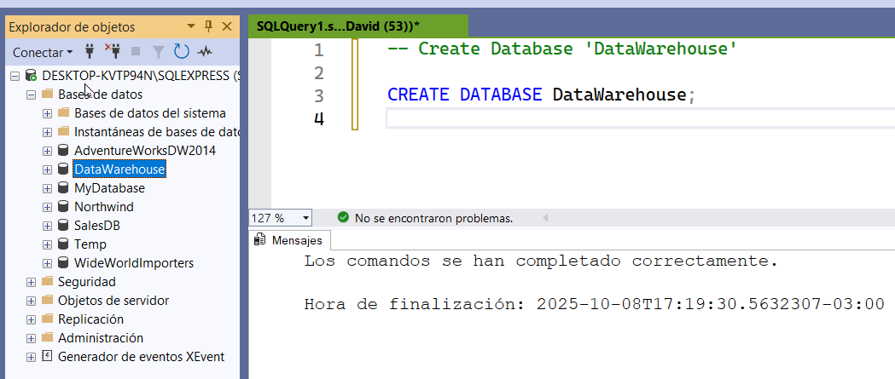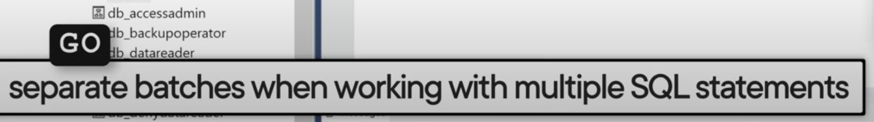

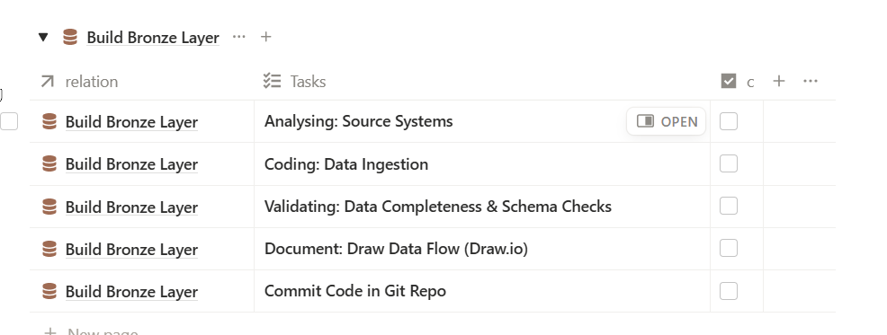



How to build the bronze layer?

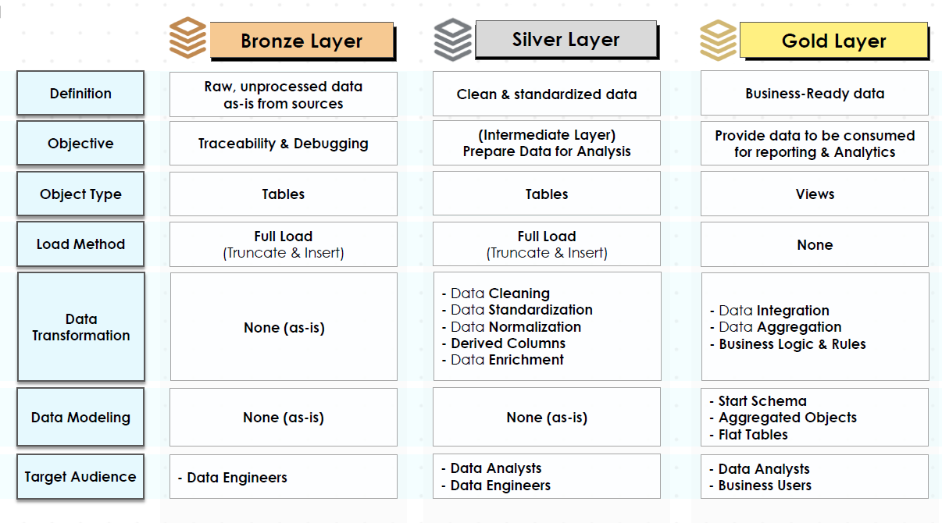

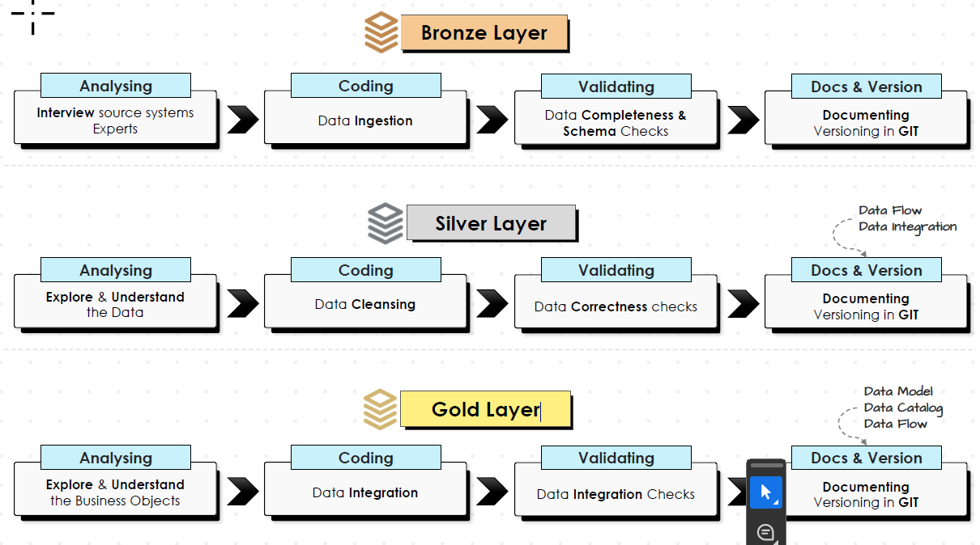



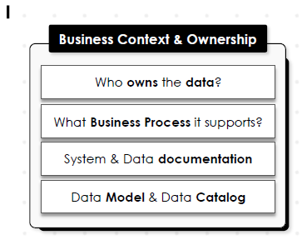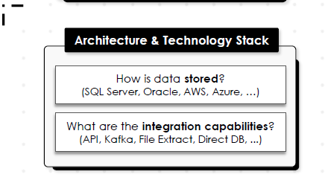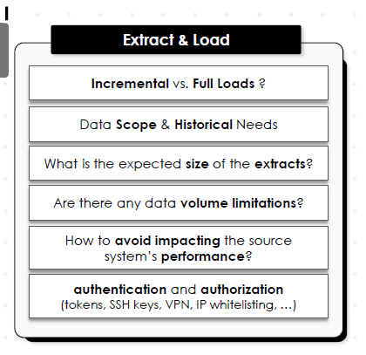

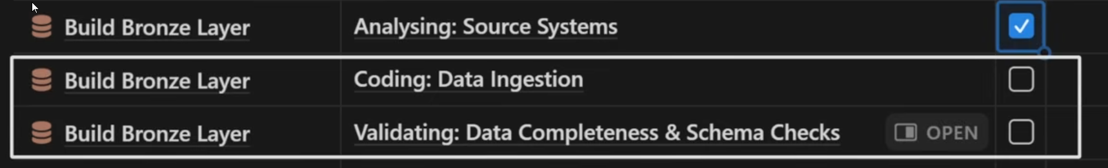

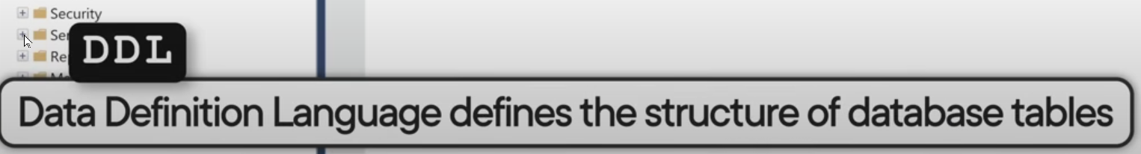

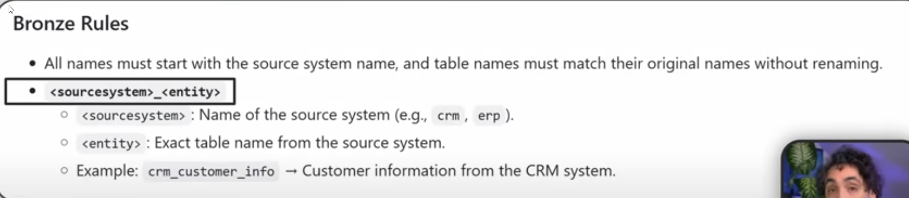

We define the **BRONZE layer**.

We start with the **system name**: crm.

Then the **table name** from the source system: cust_info.

Next, we define the **columns**

.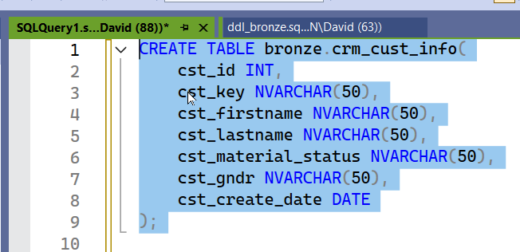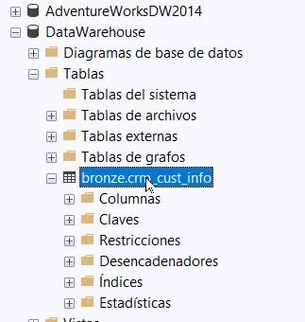

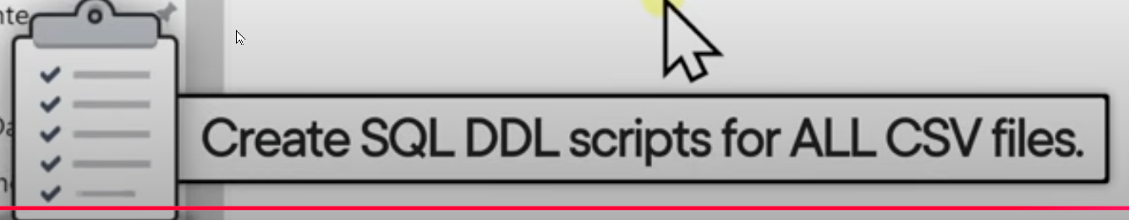

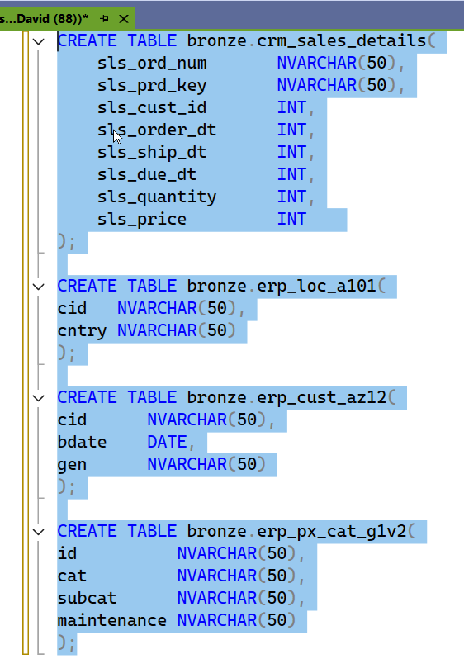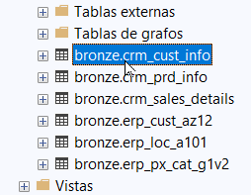

The first three tables come from the **CRM** source system, and the other three come from the **ERP** system.

We need to check if the table exists before creating it — that is, verify whether the object exists in the database.

“U” stands for **User**, meaning a user-defined table.

If the table exists in the database (is not null), then drop it and recreate it.

In other words, first drop the table if it exists, then create it from scratch.

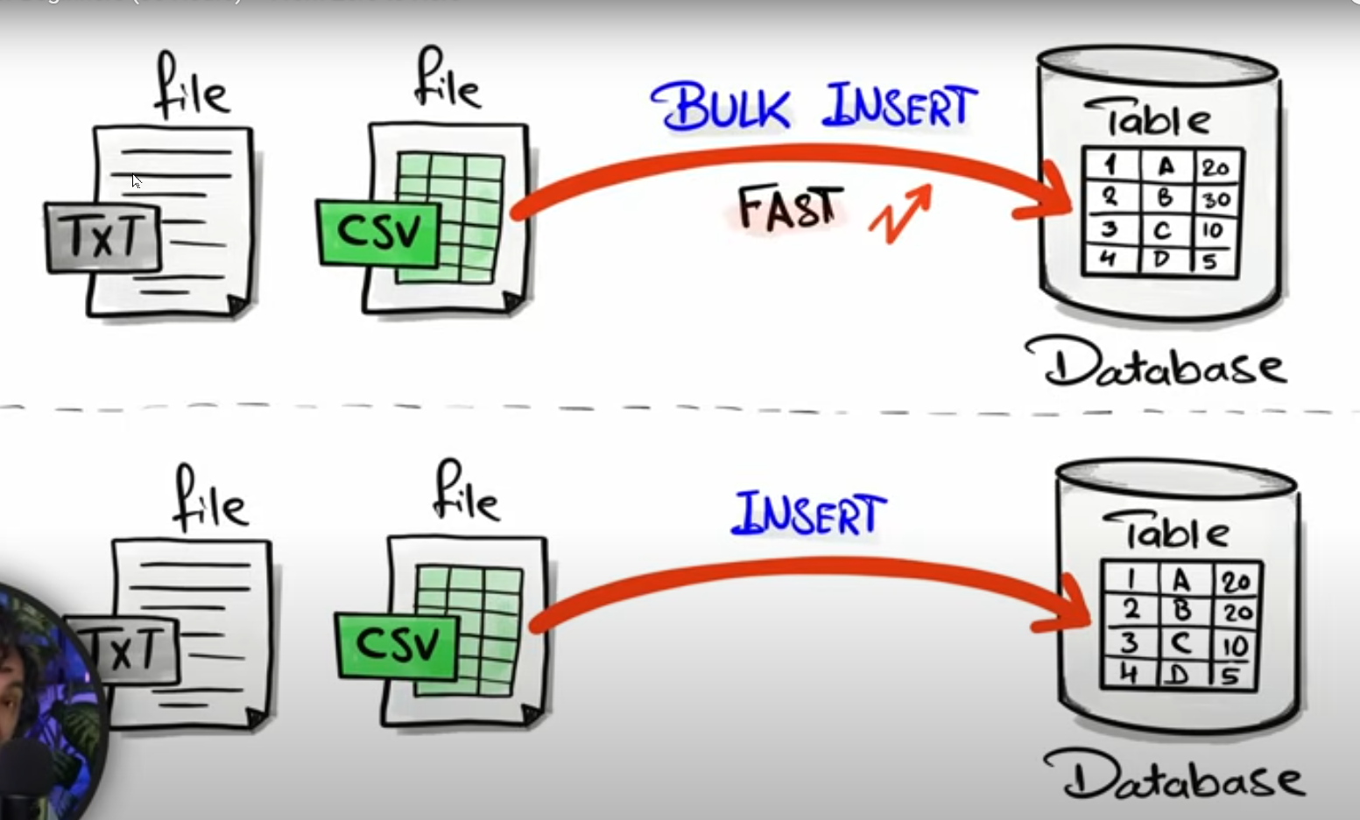

the bulk insert insert all the data in one go

We have to write the **exact file path**, otherwise it won’t work — including the **file format** where it’s stored.

Now, in the **WITH clause**, we tell SQL how to handle our file.

The first thing is the **row header** — the first row always contains the **file’s column information**.

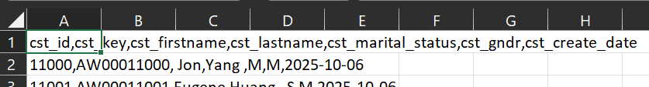

The data starts from the **second row**, so we tell SQL that the **first row** is actually the **second line** of the file — in other words, we tell SQL to **skip the first row**. Next comes the **field delimiter**. The comma (,), semicolon (;), hashtag (#), quotation mark ("), or pipe (|) can all be used as file separators or delimiters.  
 You need to understand **how your file is separated** and tell SQL accordingly — this is **crucial** for SQL to read your files correctly. Finally, **TABLOCK** is used to **improve performance** — it locks the entire table during the operation.

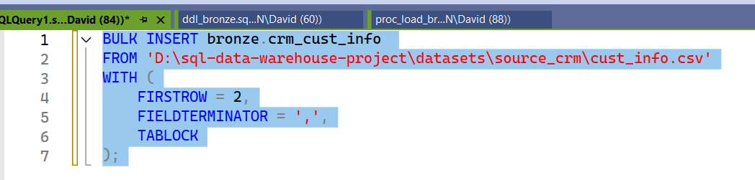

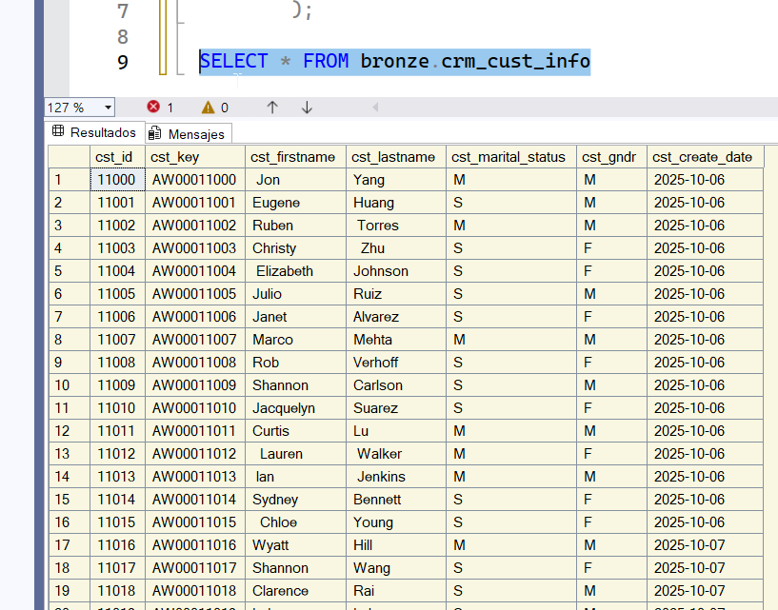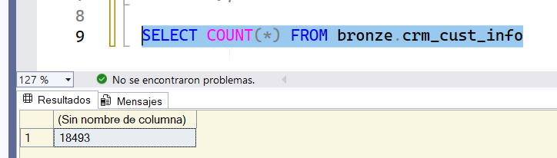

contamos las filas

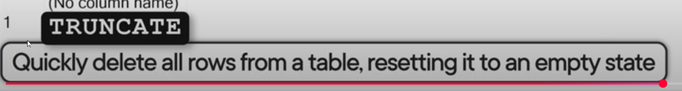

With this, we create our **empty table**, and then we **load the data from scratch**.

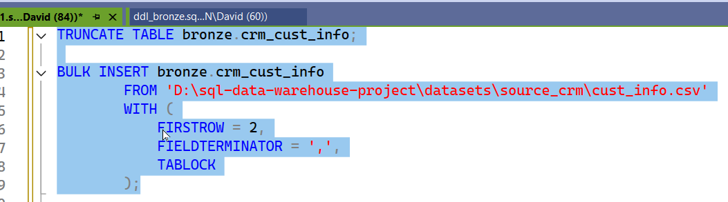

First, we perform a **TRUNCATE** to completely clear the table, and then we **INSERT the data**.

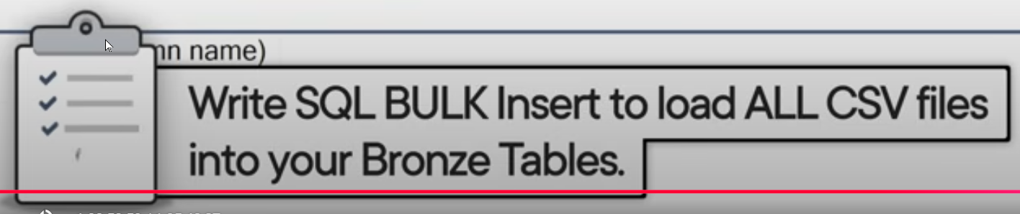

Now we need to go **table by table** and **check the content**.

.

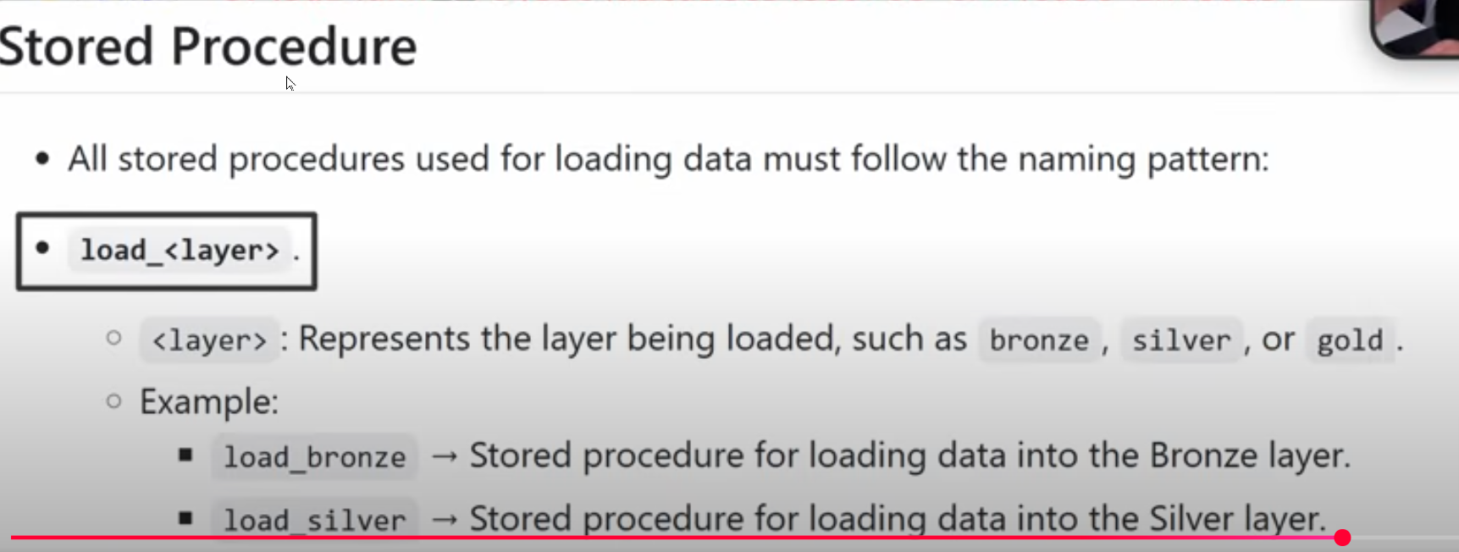

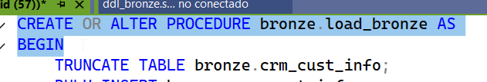

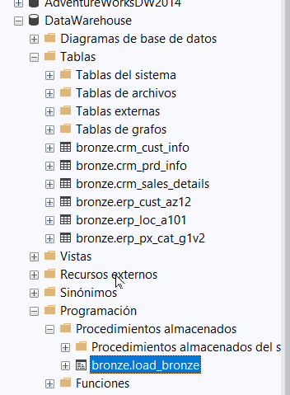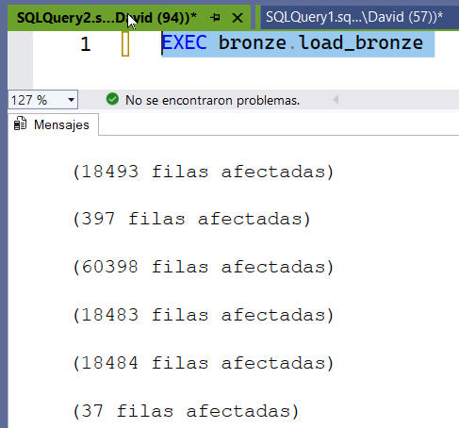luego lo probamos

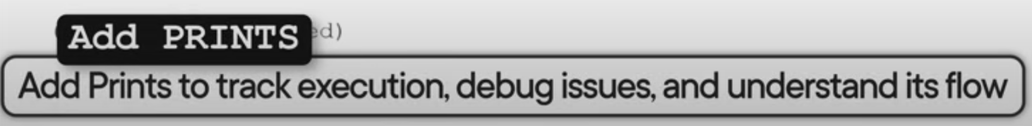

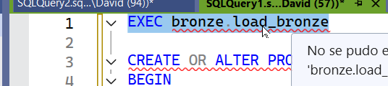

================================================

Loading Bronze Layer

================================================

-------------------------------------------------

Loading CRM Tables

-------------------------------------------------

>> Truncating Table: bronze.crm_cust_info

>> Inserting Data into: bronze.crm_cust_info

(18493 filas afectadas)

>> Truncating Table: bronze.crm_prd_info

>> Inserting Data into: bronze.crm_prd_info

(397 filas afectadas)

>> Truncating Table: bronze.crm_sales_details

>> Inserting Data into: bronze.crm_sales_details

(60398 filas afectadas)

-------------------------------------------------

Loading ERP Tables

-------------------------------------------------

>> Truncating Table: bronze.erp_cust_az12

>> Inserting Data into: bronze.erp_cust_az12

(18483 filas afectadas)

>> Truncating Table: bronze.erp_loc_a101

>> Inserting Data into: bronze.erp_loc_a101

(18484 filas afectadas)

>> Truncating Table: bronze.erp_px_cat_g1v2

>> Inserting Data into: bronze.erp_px_cat_g1v2

(37 filas afectadas)

Hora de finalización: 2025-10-09T08:37:20.9850890-03:00

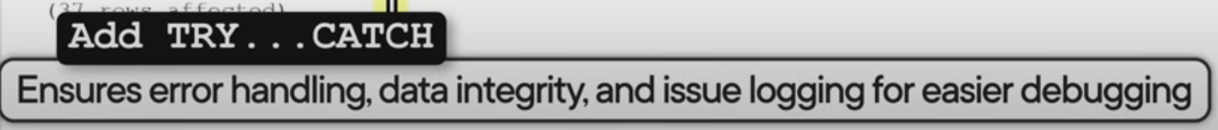

we need to handle the errors in our stored procedures

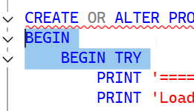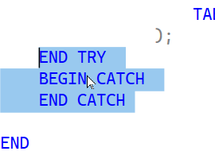

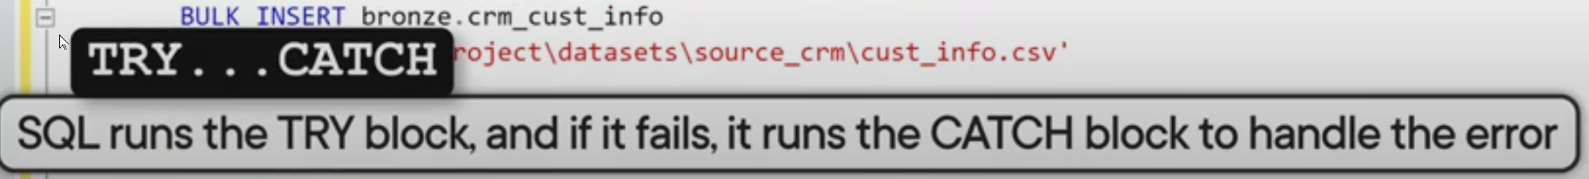

The **CATCH** block will execute **only if SQL fails to run the TRY** block.  
 Here, you tell SQL **what to do if an error occurs** in your code.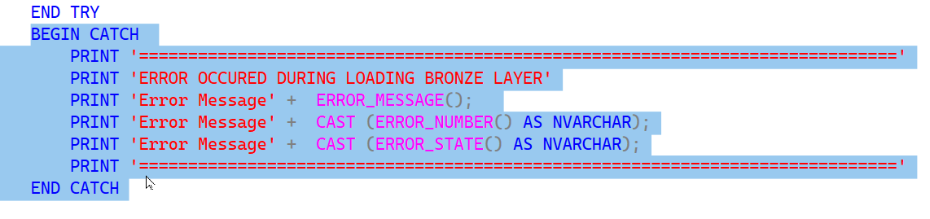



We want to know **how long it takes to load each table** — that way, you can identify which one is **consuming the most load time**. We need to **declare the variables** to measure that

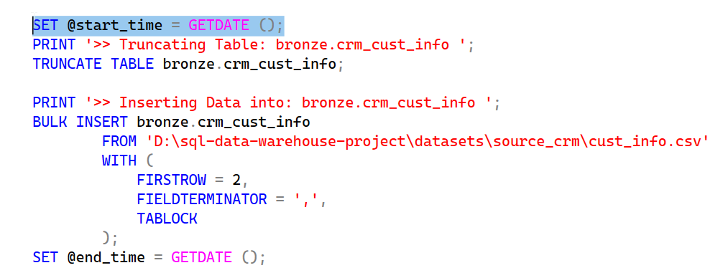

Now we have the values for when we started loading this table and when we finished loading the table. The next step is to print the duration.

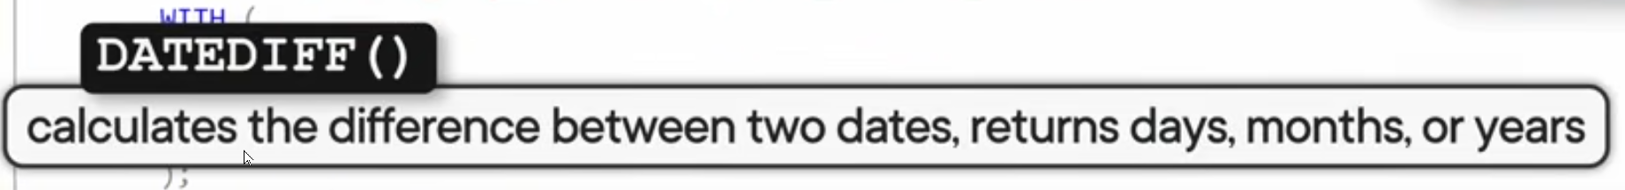

We calculate the duration.  
 We define 3 arguments: 1) unit, 2) start of the interval, and 3) end of the interval.  
 Since the result is a number, we need to cast it.  
 Then we add a separator between the tables.

